Nombre: __________________________ Bloque: ____________ Fecha: ______________________
Español 2 –Final Exam – Guía de estudio
1. Temas:
- Be able to talk about legends and ancient civilizations in Mexico.
- Be able to talk about getting around a city.
- Be able to conjugate irregular verbs in the preterite (-car/-gar/-zar, i to y, and verbs like vine, quise, traje, dije, pude, puse, etc).
- Be able to conjugate verbs in the imperfect tense.
- Be able to choose between preterite and imperfect verbs correctly.
- Be able to retell the legend of Ixta and Popo and the legend of El fuego y el tlacuache.
- Be able to tell a legend or fairytale in Spanish using the past tense.
- Be able to talk about preparing food dishes and food flavors and ingredients.
- Be able to order food and have a conversation in a restaurant.
- Be able to give formal commands.
- Be able to use direct and indirect object pronouns correctly with commands and in other types of sentences.
- Be able to make both affirmative and negative sentences and the superlative form of adjectives.
- Be able to describe culturally relevant and important food dishes from Spain.
- Be able to give informal, tú commands.
- Be able to talk about movies, film, and technology.
- Discuss the culture of México, Spain and the US.

2. Partes del examen:
Speaking Test Section – 20%
For the speaking test you will receive a prompt in either English or Spanish asking you to respond to a series of questions or provide specific information related to the themes covered in this unit. You will have up to two minutes to prepare and think of a response (only writing minimum notes – no scripts!) and then will have up to two minutes to respond to the prompt aloud, in Spanish. You will be graded on the speaking rubric.

Listening Test Section – 20%
For the listening test, you will hear various styles of listening samples in Spanish related to the vocabulary and grammar from this unit. These samples can range from conversations, advertisements, sentences, and monologues to completing dictations. Then you will have to answer comprehension questions about what you heard. These questions may be true or false statements, fill-in-the-blank statements, short answer questions, or multiple-choice questions. The listening sections will be similar to what we have practiced in class.

Reading Test Section – 20%
For the reading test, you will have to read various styles of reading samples in Spanish related to the vocabulary and grammar from this unit. These samples can range from written conversations, advertisements, sentences, and paragraphs to short stories. Then you will have to answer comprehension questions about what you heard. These questions may be true or false statements, fill-in-the-blank statements, short answer questions, or multiple-choice questions. The reading sections will be similar to what we have practiced in class and/or to the readings found in the book and workbook.

Writing Test Section – 20%
For the writing test, you will need to respond in Spanish to a given prompt. You may be asked to write an essay, write a short story, write a letter, create a written conversation, or provide another similar type of written piece. You should be prepared to write in essay form including an introduction, a conclusion, detailed supporting information, and you should make sure to have multiple, indented paragraphs. You will be graded on the writing rubric.

Vocabulary/Grammar/Culture Test Section – 20%
For this section of the test, you will have questions that will specifically target the vocabulary, grammar and culture information that was presented in this unit. It may include fill-in-the-blank questions, picture identifications, verb conjugations, multiple-choice questions, true/false questions, short answer questions, short sentence creations, etc. You should review the vocabulary list from the current unit, the notes from the current unit, and the cultural notes from the current unit in preparation.

3. Vocabulario:
el (la) dios(a) | god/goddess | el monumento | monument
el ejército | army | el objeto | object
el emperador | emperor | la pirámide | pyramid
el (la) enemigo(a) | enemy | la religión | religion
el (la) guerrero(a) | warrior | las ruinas | ruins
el héroe | hero | el templo | temple
la heroína | heroine | la tumba | tomb
el (la) joven | young man/woman | la agricultura | agriculture
la princesa | princess | cazar | to hunt
la batalla | battle | construir | to build
la guerra | war | la excavación | excavation
casarse | to get married | el (la) agricultor(a) | farmer
contar (oue) | to tell (a story); to count | los toltecas | Toltecs
llevar | to take; to carry; to wear | la acera | sidewalk
llorar | to cry | la avenida | avenue
morir (oue) | to die | el barrio | neighborhood
pelear | to fight | la catedral | cathedral
regresar | to return | la ciudad | city
transformar | to transform | la cuadra | city block
azteca | Aztec | el edificio | building
estar enamorado(a) (de) | to be in love (with) | moderno(a) | modern
hermoso(a) | handsome; pretty | la plaza | plaza; square
heroico(a) | heroic | el rascacielos | skyscraper
histórico(a) | historic; historical | ¿Cómo llego a…? | How do I get to . . . ?
querido(a) | beloved | cruzar | to cross
los celos | jealousy | doblar… | to turn . . .
tener celos | to be jealous | a la derecha | to the right
valiente | brave | a la izquierda | to the left
la montaña | mountain | seguir (ei) derecho | to go straight
el palacio | palace | desde | from
el volcán | volcano | entre | between
la leyenda | legend | frente a | across from
el mensaje | lesson; message | hasta | to
la narración | narration | (en) la esquina | (on) the corner
el personaje | character | el semáforo | traffic light
Había una vez... | Once upon a time there was/were.. | Feliz para siempre | Happily ever after
Hace muchos siglos... | Many centuries ago . . . | El pueblo | Town
sobre | about | Hace muchos años… | Many years ago…
antiguo(a) | ancient | Cerrado(a) | Closed
avanzado(a) | advanced | Perdido(a) | Lost
el calendario | calendar | Vestido(a) | Dressed
la civilización | civilization | Enojado(a) | Angry
la estatua | statue | Cansado(a) | Tired
la herramienta | tool

El aceite | Oil (for cooking) | El flan | Custard
El ajo | Garlic | El gazpacho | Cold tomato soup
El azúcar | Sugar | La paella | Traditional Spanish rice dish
La cebolla | Onion | El plato vegetariano | Vegetarian dish
Las espinacas | Spinach | El pollo asado | Roasted chicken
La fresa | Strawberry | La tarta de chocolate | Chocolate cake
La lechuga | Lettuce | El té | Tea
El limón | Lemon (sometimes a lime) | La heladería | Ice cream shop
La mayonesa | Mayonnaise | La pastelería | Pastry shop (bakery)
La mostaza | Mustard | La cuchara | Spoon
La pimienta | Pepper | El cuchillo | Knife
La sal | Salt | La servilleta | Napkin
El vinagre | Vinegar | El tenedor | Fork
La zanahoria | Carrot | El vaso | Glass
El ingrediente | Ingredient | Batido(a) | Beaten
El supermercado | Supermarket | Cocido(a) | Cooked
El sabor | Flavor | Crudo(a) | Raw
Agrio(a) | Sour | Frito(a) | Fried
Caliente | Hot (temperature) | Hervido(a) | Boiled
Delicioso(a) | Delicious | Mezclado(a) | Mixed
Dulce | Sweet | Molido(a) | Ground
Fresco(a) | Fresh | La mantequilla | Butter
Picante | Spicy; hot (spiciness) | La lima | Lime (in Mexico – a lemon)
Sabroso(a) | Tasty | Poner en el horno | To put in the oven/bake
Salado(a) | Salty | Revolver (o-ue)/Mezclar | To stir; to mix
¡Qué asco! | How disgusting! | Cocinar | To cook
Añadir | To add | El mantel | Tablecloth
Batir | To beat | Una taza | A cup; a mug
Freír (e-i) | To fry | Una taza medidora | A measuring cup
Hervir (e-ie) | To boil | Un cuarto de taza | A quarter cup
Mezclar | To mix | Un tercio de taza | A third of a cup
Probar (o-ue) | To taste; to try | Una media taza | A half-cup
La receta | Recipe | Una cucharadita | Teaspoon (measure)
La tortilla de patatas | Potato omelet | Una cucharada | Tablespoon (measure)
Cenar | To have dinner | El plato | Plate
Desayunar | To have breakfast | Un bol; un tazón; un cuenco | A bowl
La merienda | Afternoon snack | Una sartén | A frying pan
¿Cuál es la especialidad de la casa? | What is the specialty of the house? | Una olla; una cacerola | A saucepan; a pot
¿Me puede traer…? | Can you bring me…? | El horno | The oven
Y para comer… | And to eat… | Cortar | To cut
Y para beber… | And to drink…. | Poner la mesa | To set the table
¡Buen provecho! | Enjoy! (Bon apetit!) | El camarero | Waiter
¡Excelente! | Excellent! | Una propina | A tip
Muy amable | Very kind | La cuenta | The bill
Muy atento(a) | Very attentive | El cocinero | The cook
Gracias por atenderme | Thank you for your service | El jefe de cocina | The chef
El caldo | Broth | Pedir (e-i) | To order food; to ask for
La chuleta de cerdo | Pork chop | Servir (e-i) | To serve
El entremés | Appetizer | Reservar | To reserve
Los espaguetis | Spaghetti | Dejar (una propina) | To leave (behind) (a tip)
La especialidad | Specialty | La comida está buena. | The food is (tastes) good.
El filete a la parrilla | Grilled steak | La comida está mala. | The food is (tastes) bad.
¿Para ti? | For you? | La comida es buena. | The food is good (for you).
Para mí… | For me… | La comida es mala. | The food is bad (for you).

El argumento | The plot | El teléfono celular | Cellular phone
Editar | To edit | ¿Aló?, ¿Bueno?, ¿Diga? | Hello?
Los efectos especiales | Special effects | ¿Está…? | Is … there?
La escena | Scene | No, no está. | No, he’s/she’s not.
Esperar | To wait (for); to hope (for) | Un momento | One moment
Filmar | To film | ¿Puedo hablar con…? | May I speak to…?
Fracasar | To fail | ¡Cómo no! | Of course!
El guión | Screenplay; script | ¡Estoy convencido(a)! | I’m convinced!
Hacer un papel | To play a role | ¡Te digo la verdad! | I’m telling you the truth!
El maquillaje | Makeup | Te lo aseguro. | I assure you.
El sonido | Sound | ¡Te lo juro! | I swear to you!
Tener éxito | To be successful | La invitación | Invitation
La cámara de cine | Movie camera | El fin de semana | Weekend
La cámara digital | Digital camera | El (la) próximo(a) | Next
La cámara de video | Video camera | ¡Claro que sí! | Of course!
El micrófono | Microphone | ¡Qué lástima! | What a shame!
El software | Software | Sí, me encantaría. | Yes, I would love to.
El actor | Actor | La corbata | Tie
La actriz | Actress | El corbatín | Bow tie
El (la) camarógrafo(a) | Cameraman/woman | La gala | Gala; formal party
El (la) director(a) | Director | La ropa elegante | Formalwear
La estrella de cine | Movie star | Estrenar | To premiere
Famoso(a) | Famous | El estreno | The premiere
La gente | People | La crítica | Review
El (la) guionista | Screenwriter | ¡Ojalá! | I hope so!/Oh how I wish/Hopefully
La animación | Animation | Estoy muy emocionado(a) | I’m overcome with emotion.
La comedia | Comedy | Quisiera darle(s) las gracias a … | I would like to thank…
El documental | Documentary | El telefóno celular (Lat. Amer) | Cellphone
El drama | Drama | El teléfono móvil (Spain) | Cellphone
La película… | …. film/movie | El celular (Lat. America) | Cell
de aventuras | action | El móvil (Spain) | Cell
de ciencia ficción | science fiction | La tableta | Tablet (computer)
de fantasía | fantasy | Descargar | To download
de terror | horror | Subir | To upload; to go up
Me da miedo. | It scares me. | La app; la applicación | App; application
Me hace reír. | It makes me laugh. | Cargar | To charge
Me hace llorar. | It makes me cry. | Un cargador | A charger
La dirección electrónica | Email address | El email | Email
Estar en línea | To be online | Enviar un correo electrónico | To send an email
Hacer clic en | To click on | El archivo | The file
El icono | Icon | Googlear | To google
El mensajero instantáneo | Instant messaging | Postear | To post
El ratón | Mouse | Un aporte | A post
El teclado | Keyboard | Un enlace | A link
Dejar un mensaje | To leave a message

3. Gramática:
Pretérito de verbos -AR:  - É - AMOS  - ASTE - ASTEIS  - Ó - ARON | Pretérito de verbos –ER/-IR:  - Í - IMOS  - ISTE - ISTEIS  - IÓ - IERON

Los verbos –car/-gar/-zar:
-CAR/-GAR/-ZAR Verbs: Change in the yo form, rest of forms are normal.
-CAR: -qué, -GAR: -gué, -ZAR: -cé

Buscar – To look for  - Busqué - Buscamos  - Buscaste - Buscasteis  - Buscó - Buscaron  Jugar – To play  - Jugué - Jugamos  - Jugaste - Jugasteis  - Jugó - Jugaron | Empezar – To begin  - Empecé - Empezamos  - Empezaste - Empezasteis  - Empezó - Empezaron  Other –car/gar/zar verbs:  Comenzar, autorizar, cruzar, almorzar, tocar, sacar, practicar, empacar, llegar, pagar, regar, colgar.

Los verbos irregulares del pretérito:
Ir – to go/Ser – to be  Fui Fuimos  Fuiste Fuisteis  Fue Fueron  Hacer – to do/make  Hice Hicimos  Hiciste Hicisteis  Hizo Hicieron | Ver – to see  Vi Vimos  Viste Visteis  Vio Vieron  Dar – to give  Di Dimos  Diste Disteis  Dio Dieron

i to y verbs:
Leer – to read  Leí Leímos  Leíste Leísteis  Leyó Leyeron | Construir – to build  Construí Construimos  Construiste Construisteis  Construyó Construyeron

Los verbos irregulares del pretérito:

I Group:  Hacer – to do/make  _____________-  Venir – to come  _____________-  Querer – To want (tried/refused)  _____________-  UV Group:  Tener – To have  _____________-  Estar – To be  _____________-  Andar – To walk (through)  _____________- | U Group:  Poner – To put  _____________-  Poder – To be able to (managed)  _____________-  Saber – To know (found out)  _____________-  J Group:  Decir – To say/tell  _____________-  Traer – To bring  _____________-  Conducir – To drive  _____________- | Irregular Endings:  -e -imos  -iste -isteis  -o -ieron

Stem-change verbs in the Preterite:
EI – Pedir – to ask for/order  - Pedí - Pedimos  - Pediste - Pedisteis  - Pidió - Pidieron  OU – Dormir – to sleep  - Dormí - Dormimos  - Dormiste - Dormisteis  - Durmió - Durmieron | EI - Preferir - to prefer  - Preferí - Preferimos  - Preferiste - Preferisteis  - Prefirió - Prefirieron  EI – Vestirse – to dress oneself  - Me vestí - Nos vestimos  - Te vestiste - Os vestisteis  - Se vistió - Se vistieron

Imperfect:
Verbos de –AR  - aba - ábamos  - abas - abais  - aba - aban  Verbo Ser – To be  - Era - Éramos  - Eras - Erais  - Era - Eran | Verbos de –ER/-IR  - ía - íamos  - ías - íais  - ía - ían  Verbo Ir – To go  - Iba - Íbamos  - Ibas - Ibais  - Iba - Iban

Pretérito vs. Imperfecto:
Preterite is used for actions that are completed in the past, had a specific beginning or end in the past, or were repeated a specific number of times in the past. Any specific time/day mentioned is used with preterite (Ayer, anoche, la semana pasada, el año pasado, etc). Can pinpoint preterite on a timeline.
Imperfect is used for actions/descriptions that have the meaning “used to ...” or “was doing...”. Imperfect is used for description, time, age, etc. It is used for actions that are still ongoing. Associated with words like siempre, todo el tiempo, cada día, cada año. Cannot pinpoint imperfect on a timeline.
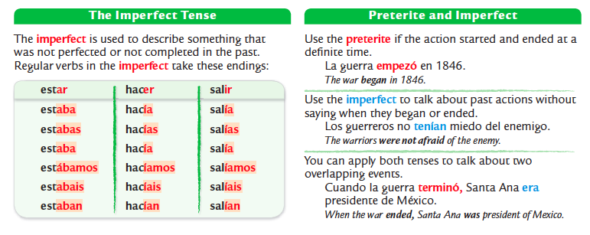
Imperativo/Mandatos Formales: Meaning – ¡Hable usted! Speak!
Used only with USTED/USTEDES. Formal commands.

-AR Verbs:
Usted | Ustedes
-e | -en
-ER/IR Verbs:
Usted | Ustedes
-a | -an

Ejemplo – Hablar – to speak/talk:
Usted | Ustedes
¡Hable ud.! | ¡Hablen uds.!

Ejemplo – Escribir – to write:
Usted | Ustedes
¡Escriba ud.! | ¡Escriban uds.!

Irregulares:

Poner – to put:
¡Ponga ud.! | ¡Pongan uds.!

Decir – to say:
¡Diga ud.! | ¡Digan uds.!

Venir – to come:
¡Venga ud.! | ¡Vengan uds.!

Salir – to leave:
¡Salga ud.! | ¡Salgan uds.!

Hacer – to do/make:
¡Haga ud.! | ¡Hagan uds.!

Ser – to be (description, permanent):
¡Sea ud.! | ¡Sean uds.!

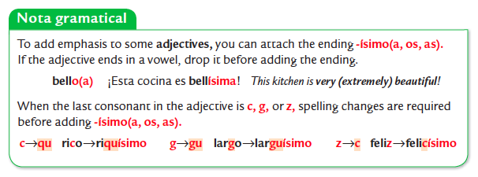
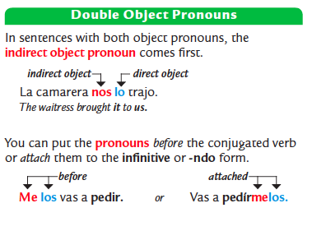
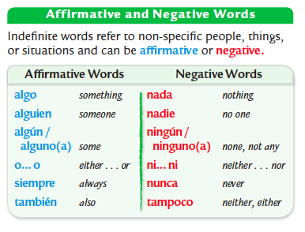
Ir – to go:
¡Vaya ud.! | ¡Vayan uds.!

Saber – to know (facts):
¡Sepa ud.! | ¡Sepan uds.!
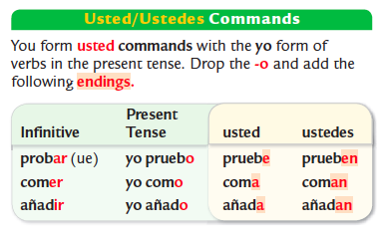
Conocer – to know (people_:
¡Conozca ud.! | ¡Conozcan uds.!

Introducir – to introduce
¡Introduzca ud.! | ¡Introduzcan uds.!

Estar – to be (temporary):
¡Esté ud.! | ¡Estén uds.!

Dar – to give:
¡Dé ud.! | ¡Den uds.!
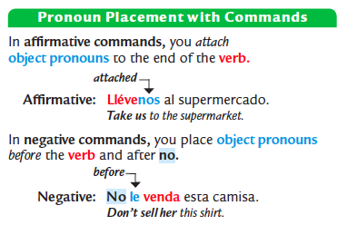

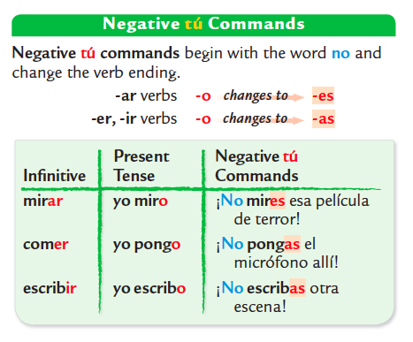
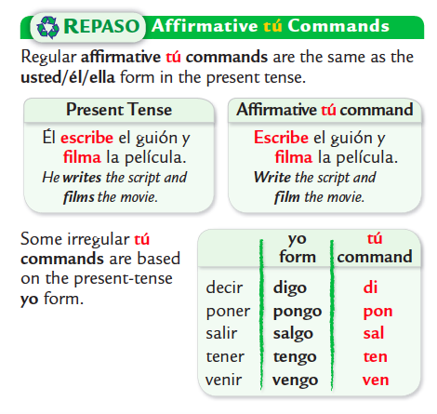

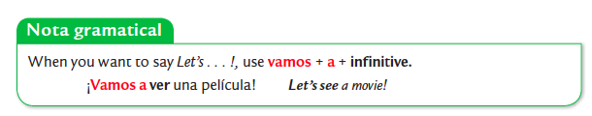

4. Cultura:
México:
Datos generales y geográficos:
- La Ciudad de México/Mexico City/México D.F. is the capital of Mexico
- Common languages: Spanish & indigenous languages like Nahuatl, Maya
- Typical Food: Tamales, enchiladas, tacos

Ancient Civilizations:
The Aztecs:
- The Aztec Empire, located in central Mexico, had a capital city of Tenochtitlán, which is where modern day Mexico City is located.
- The myth of Ixtaccíhuatl and Popocatépeti explains the origins of two volcanoes in Mexico.
- Huitzilopochtli was an Aztec god of war, sun, human sacrifice and of Tenochtitlán.

Frida y Diego:
- Frida Kahlo and Diego Rivera were famous artists from México.
- Frida Kahlo was known for her self-portraits or autorretratos with fantastical and surrealistic elements.
- Diego Rivera was known for his murals which reflected Mexican history and often had political and cultural themes.

El fuego y el tlacuache:
- "El fuego y el tlacuache" is a mazateca legend (leyenda mazateca) about the origins of fire.
- Tlacuache is the brave opposum (hero of the story) who brought the fire to the rest of the village.

España:
Datos generales y geográficos:
- Madrid is the capital of Spain.
- Typical Foods: Gazpacho (cold tomato soup with raw vergetables), paella (rice dish with saffron), ensaladilla rusa (potatoes, vegetables, mayonnaise), flan (custard deserrt), churros (fried dough) con chocolate caliente (popular breakfast food from Spain)

Las tapas:
- Tapas are small portions of food and are very common in Spain.
- A common tapa la torilla de patatas (tortilla española) which is different than tortillas from Mexico/Central America. A tortilla española is made with egg, potatoes and onion. A tortilla mexicana is made of flour or corn.

El Greco:
- El Greco was the nickname of Doménikos Theotokópoulos, born in Greece/Grecía, but who became a famous artist in Spain.
- El Greco lived for many years in Toledo, Spain which is near Madrid.
- A famous painting by him is Vista de Toledo.

Antoni Gaudí:
- Antoni Gaudí was a famous catalán architect (arquitecto) from Barcelona, Spain in the region of Cataluña.
- Gaudí was a modernist and built decorative buildings and locations in Barcelona, drawing inspiration from nature and fantasy with bright colors and curving shapes.

Pablo Neruda:
- Pablo Neruda was a famous poet from Chile.
- Pablo Neruda wrote many odas/odes to various every day objects (las cosas más básicas de la vida).

Estados Unidos:
Chicanos & Arte:
- Chicano is a word for Mexican Americans - people born (nació) in the United States but of Mexican heritage (herencia mexicana).
- Gilbert "Magu" Lujan, a Chicano painter, formed part of "Los Four" and also painted many murals in the city of LA.
- Aztlán is a common theme in Chicano art and is the legendary origin place of the Aztecs.

Mexicanoamericanos & Los Ángeles:
- A little over 45% of the population of Los Angeles is Latino.
- The Spanish farmers founded a city in California and named it «El Pueblo de Nuestra Señora la Reina de los Ángeles del Río de Porciúncula» - today we call it Los Angeles.

